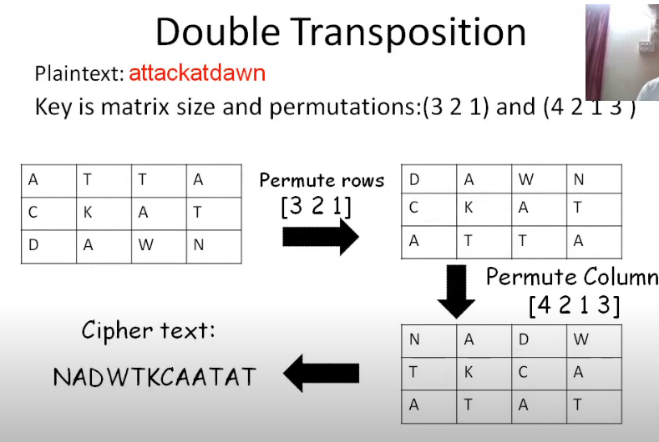

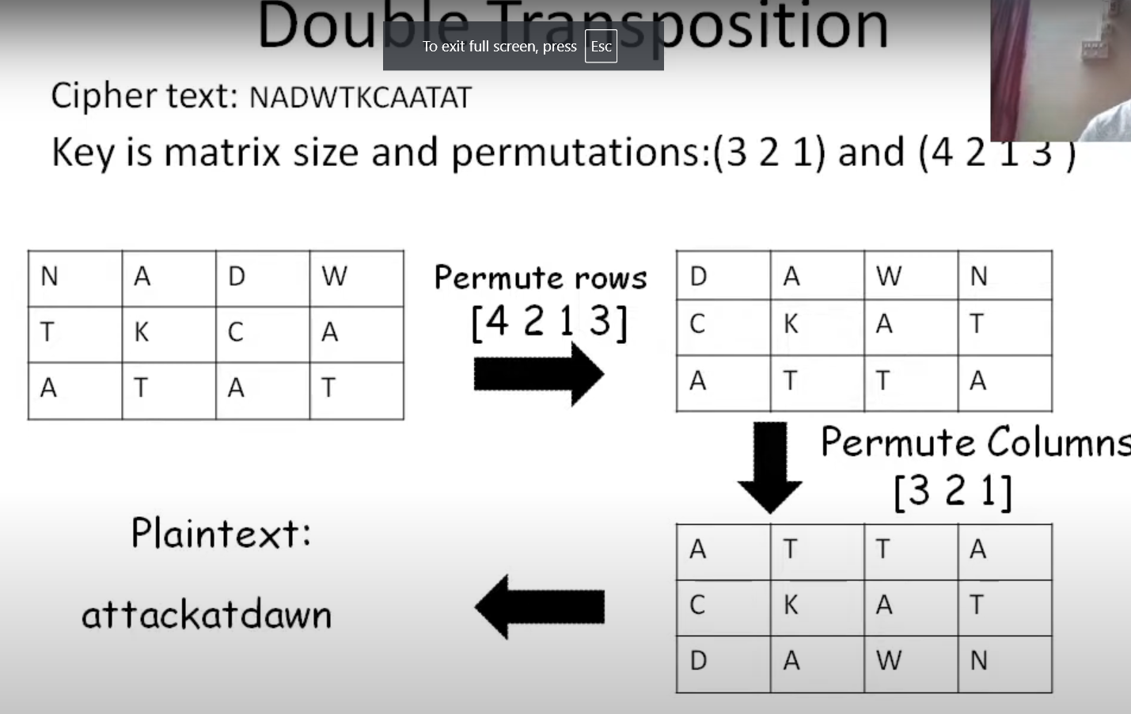

One-time pad: https://www.youtube.com/watch?v=6iYqHn3q8sY